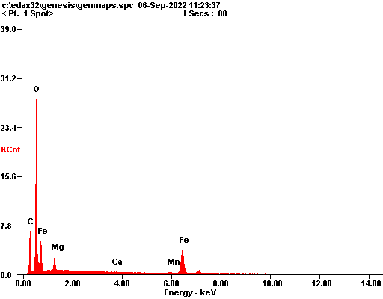

|  |  |  |
| --- | --- | --- |
| ***Element*** | ***Wt%*** | ***At%*** |
| ***CK*** | 19.88 | 33.52 |
| ***OK*** | 39.56 | 50.07 |
| ***MgK*** | 03.52 | 02.93 |
| ***CaK*** | 00.25 | 00.13 |
| ***MnK*** | 01.16 | 00.43 |
| ***FeK*** | 35.63 | 12.92 |
| ***Matrix*** | Correction | ZAF |

